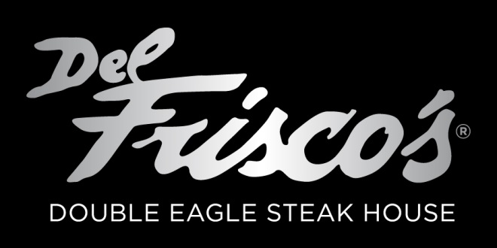
Golf Experience 2015
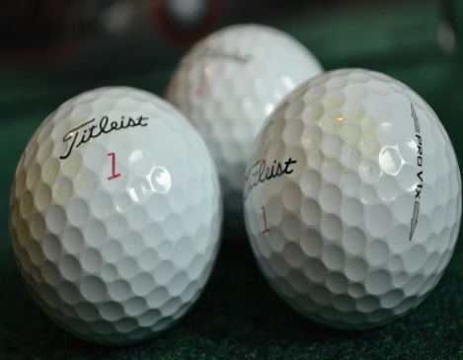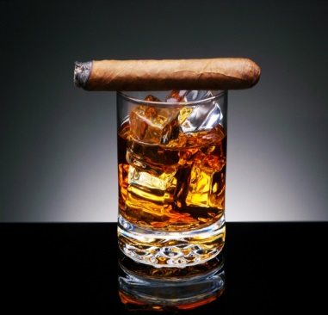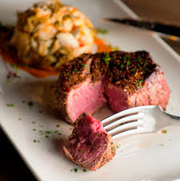
THE OPPORTUNITY
• Develop your association with an important cause
• Host key clients in an enjoyable and stress-free setting
• Network with leaders in the business community
• Showcase your brand to a desirable target audience

Custom packages are available at Golf Course sponsorship level and above to meet your marketing needs.
Ways for corporations to be involved: sponsorship, gifts-in-kind, corporate foursomes and donations.
Host Sponsor - $20,000
• Official designation as the Host of the event
• Category exclusivity
• Accommodations for twenty four dinner guests for Del Frisco’s Double Eagle Steakhouse event on Sunday, October 4th
• Three Foursomes Glenmoor Country Club on Monday, October 5th
• 12 Mulligan’s (one for each golfer)
• Logo recognition as Host Sponsor in all live, print and electronic event materials
• Logo on dinner menu
• Marketing display table at the event
• Opportunity to have logo on premium product
•Logo on Hole 1 and 18

Presenting Sponsor - $15,000
• Official designation as the Presenting Sponsor
• Category exclusivity
• Accommodations for sixteen dinner guests at Del Frisco’s Double Eagle Steakhouse event on Sunday, October 4th
• Speaking opportunity at dinner / auction
• Two Foursomes at Glenmoor Country Club on Monday, October 5th
• 8 Mulligan’s (one for each golfer)
• Logo recognition as Presenting Sponsor in all live, print and electronic event materials
• Logo on dinner menu
• Marketing display table at the event
•Logo on 3 and 9
GOLF EVENT
SPONSORSHIP OPPORTUNITIES
Golf Course Sponsor - $10,000
• Official designation as a Golf Course Sponsor
• Accommodations for eight dinner guests at Del Frisco’s Double Eagle Steakhouse event on Sunday, October 4th
•Speaking opportunity at dinner/ auction
• One Foursome at Glenmoor Country Club on Monday, October 5th
• 4 Mulligan’s (one for each golfer)
• Sponsor listing on dinner menu
•Logo on Hole in One Hole
Golf Cart Sponsor - $5,000
• Accommodations for four dinner guests at Del Frisco’s Double Eagle Steakhouse event on Sunday, October 4th
Signage on the cart / putting green
• One Twosome at Glenmoor Country Club on Monday, October 5th
• 2 Mulligan’s (one for each golfer)

Individual Golf Sponsor - $1,000
• Accommodations for two dinner guests at Del Frisco’s Double Eagle Steakhouse event on Sunday, October 4th
Signage on the course
• One Mulligan

Hole Sponsor - $500
• Accommodations for two dinner guests at Del Frisco’s Double Eagle Steakhouse live on Sunday, October 4th
Signage on the course

Hole in One Car Sponsor
• Accommodations for two dinner guests at Del Frisco’s Double Eagle Steakhouse event on Sunday, October 4th

Silent Auction Sponsor
• Sponsor listing on dinner menu• Recognition on signage at the silent auction
Benefits:
